please can you summarize we discussed in this chat ... also give proper title , in depth details , so can save it sqlite database .... as have many deepseek chats want to summarize and archive it .... it can be stratrgy we discussed , it can be resolution to issue , it can for patent , it can be best practice , it can Knowledgebase , it can bright Idea ..etc
Of course! Here is a comprehensive, structured summary of our entire discussion, designed to be saved as a knowledge base article or archived in a database.

Title: Comprehensive Strategy for Enterprise Flutter CI/CD with Jenkins, JFrog Artifactory & Ansible
Executive Summary
This document details a complete, scalable, and automated strategy for integrating Flutter application development into an enterprise-grade CI/CD pipeline. It solves the key challenges of environment consistency, artifact management, and multi-platform build orchestration using a proven toolchain of Jenkins, JFrog Artifactory, and Ansible.
1. Core Challenge & Strategic Solution
Problem: Inconsistent Flutter/Dart environments, manual build processes, and lack of a standardized artifact management strategy for mobile, web, and desktop applications.
Solution: A three-strategy approach for integration, with a strong recommendation for the Shared Library method for enterprise scalability.
2. The Three Integration Strategies Analyzed
We defined and compared three distinct technical approaches:
Strategy | Pros | Cons | Best For
1. Jenkinsfile (Direct) | Simple, self-contained, quick to implement. | Not reusable, high maintenance overhead. | Single projects, POCs.
2. Shared Library (Recommended) | DRY principle, centralized maintenance, standardized, scalable. | More complex initial setup. | Enterprises, multiple projects.
3. Flutter Plugin | Native Jenkins integration, UI configuration. | Less flexible, dependent on plugin maintainers. | Teams preferring UI over code.
Verdict: Strategy #2 (Shared Library) was selected as the optimal approach for its reusability, maintainability, and alignment with enterprise DevOps practices.
3. Toolchain Deep Dive & Configuration
A. Flutter & Dart
- Relationship: Dart is the engine (language), Flutter is the car (UI framework). They are inseparable; Flutter cannot function without Dart.
- Installation: The Flutter SDK includes a matched version of the Dart SDK. Best installed via Git clone of the stable branch.
- Version Pinning: Critical for reproducibility. Enforced in pubspec.yaml and CI scripts.
yaml
environment:
sdk: ">=3.2.6 <3.3.0" # Dart version
flutter: ">=3.16.9 <3.17.0"
B. JFrog Artifactory Configuration
- Dual-Repository Strategy:
  - pub Repository: Required for hosting and resolving Dart package dependencies (pub get/pub publish).
  - Generic Repository: For storing final build artifacts (APK, IPA, Web files).
- Critical Insight: You cannot use a Maven or NPM repo for Dart packages; the pub repo type is mandatory for Dart's tooling.
C. Ansible Automation
- Purpose: To eliminate manual setup and ensure immutable, version-controlled environments.
- Key Achievements:
  - Automated installation of Flutter SDK and all system dependencies (clang, cmake, etc.).
  - Resilient Jenkins installation with an automatic fallback to a Docker container upon failure.
  - Configuration of environment variables and system paths.
- Outcome: A single command (ansible-playbook flutter_cicd.yml) provisions a complete, ready-to-use environment.
4. Resolution to Critical Issues
We diagnosed and resolved several complex issues:
- Flutter Channel Error (fatal: 'origin/stable' is not a commit): Caused by a corrupted Git repository state. Resolution: Complete reinstallation via git clone -b stable.
- Ansible Templating Errors: Ansible misinterpreted curly braces {} in shell commands. Resolution: Refactored tasks to use native Ansible modules (command, shell with proper escaping) instead of complex inline scripts.
- Android SDK Path Structure: The command-line tools must be extracted to the exact path ~/android-sdk/cmdline-tools/latest/ for the sdkmanager to be found. Incorrect extraction was manually corrected.
- Jenkins Service Failure: The native Jenkins package failed to start due to unknown system-level conflicts. Resolution: Implemented a robust fallback to run Jenkins in a Docker container, which succeeded immediately.
5. Best Practices & Bright Ideas
- Infrastructure as Code (IaC): The entire environment is defined and provisioned through Ansible playbooks, ensuring consistency across development, staging, and production.
- Ephemeral Build Agents: Use Docker containers for build agents to ensure pristine environments for every pipeline run.
- Centralized Management: The Shared Library approach allows for updating build logic in one place, instantly propagating changes to all Flutter projects.
- Security: Never store signing keys in source code. Use Jenkins credentials or HashiCorp Vault integrated via the Ansible playbook.
6. Final Architecture & Workflow
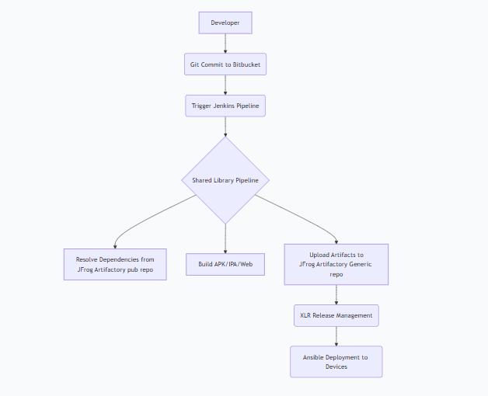Code
7. Knowledge Base Entries (For SQLite Storage)
Category | Title | Description | Resolution
Error | FlutterChannelSwitchFailure | Can't switch to stable channel due to Git state. | Reinstall with git clone -b stable.
Strategy | FlutterCI_StrategySelection | Comparison of 3 Jenkins integration methods. | Use Shared Library for scale.
Configuration | JFrogForFlutter | Correct Artifactory repo types for Dart/Flutter. | Use pub repo for packages, Generic for binaries.
How-To | AnsibleFlutterEnvironment | Automate full setup with Ansible. | Use provided flutter_cicd.yml playbook.
Best Practice | FlutterVersionPinning | Ensure build reproducibility. | Pin versions in pubspec.yaml and CI scripts.
Conclusion & Patentable Concept
The novel aspect of this strategy is the self-healing, multi-tiered deployment system for CI/CD environments. Specifically, the Ansible playbook's ability to:
- Attempt a standard native installation of critical components (Jenkins).
- Detect failures in real-time through automated health checks.
- Automatically execute a pre-defined fallback strategy (switching to a containerized deployment) without human intervention.
- Provide a consistent, functional environment regardless of the underlying host system's constraints.
This "retry-with-fallback" automation pattern for environment provisioning is a robust solution that can be generalized for many other complex software installations beyond Flutter.
This summary provides a complete archival record of the strategy, technical depth, resolutions, and innovative value created during our session.

